Chapter Notes – Flow of Goods and Services
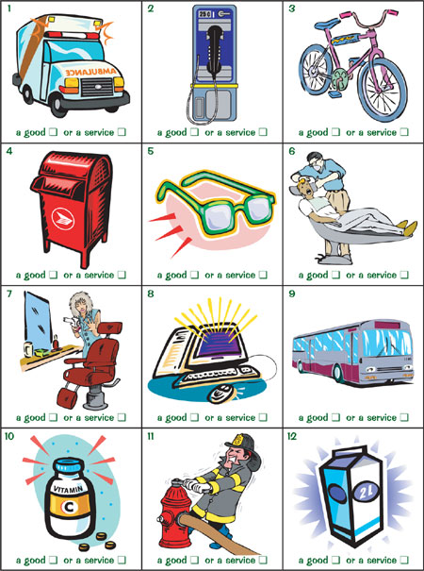

Read the second section, Flow of Goods and Service s (pgs. 128-133), in your textbook, and answer the following questions:
- Make a list of the goods that come into Canada.

- Explain the difference between trade deficits and trade surpluses.

- Explain why governments prefer to have trade surpluses instead of trade deficits.

- Explain the difference between direct and indirect exporting. What type of company is likely to use each type of exporting?

- Explain five ways a business can offset the risks of importing.

- What agencies can help exporters learn more about foreign markets?

- List three reasons why the United States is Canada’s number on trading partner.

