Income Statement Error Review Activity
Discussion - Income Statement Errors
- Ming Lam’s bookkeeper prepared the following income statement for her first year in business. It appears that Ming needs a new bookkeeper. She wants you to help find the errors in this income statement.
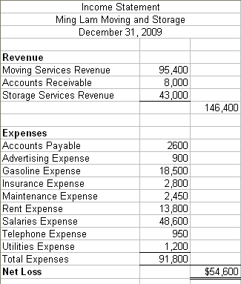
- Download the spreadsheet to look for the mistakes. Correct all of the errors on the spreadsheet.
- Describe all errors and the necessary corrections.

