Photo Assignment One
Your task here is to shoot and edit at least three superb photos that would be suitable for three different yearbook features you’re assigned to. This will be useful when you create the pages, and fun, but remember that we’re looking for extremely good photos here, so spend some time to do your best. If you need help, ask, but make sure you’re been listening in class and are aware of the help available on our website.

Specifications
- Take at least 15 photos of people – pick 3
- Relevant to sections of the yearbook you’re assigned to (one can just be a general “Student Life” even if you’re not part of that section). If you can’t shoot pictures for one or more of your pages because they won’t happen until later in the year, you can “pretend” you’re in another section. You can also stretch things a bit, such as a shot from a PhysEd class for sports.
- Interesting subject involved in some activity, showing strong expression
- At least one candid and one posed
- Well composed – see “Photo tips” and look at lots of examples from other yearbooks, Look-books etc.
- Lighting must be perfect – well-thought out and purposeful
- one indoors with a flash and one indoors with no flash *ask someone to show you how to alter the flash if you’re not sure.

Where?
Each student has his or her own folder under the Yearbook icon under “Members” Save all your photos as Jpegs there. I will likely also ask you to upload the photos to the EDesign website and place them temporarily on a page as part of the next assignment.

NEW : Filenames
Please change the filenames to reflect the criteria that you’re trying to cover with them.
Example: The picture below might have been for “student life” (all of you can shoot one picture from this category). It’s candid, indoors, no flash, so I’d name it like this:
Stulife_indoors_candid_noflash.jpg
Be sure not to change the .jpg extension!
Another random example might be GRADS_fillflash_posed.jpg

When?
The photos must be in place by Mon. Sept. 26th by the end of the period.

Yes, you can borrow a camera if you need to. Any of our digital cameras can take great photos. But it’s easier if you bring your own camera to school.

Assignment:
- Copy your three (3) chosen photos into a MS Word File.
- Write a reflection on the three photos. Be sure to include:
  - Setting used on your camera (be sure to use three different settings)
  - Explain how you thoughtfully composed your photo
  - Explain how you chose your lighting/the flash.
  - Use terminology from the Photography tips and handouts.

Example of a Suitable Photo
This isn’t technically or artistically perfect, but it is good because:
- It’s intense – look at the concentration of the player
- The other students are also showing emotion and concentration
- They’re ignoring the camera (well okay, one guy is looking at it, but the rest are candid…)
- The lighting is good – not perfect, but not bad for indoors without a flash, into a strong backlight
- The two most important faces are close to rule of thirds positions
- There’s an appealing amount of colour
- There’s enough contrast to be vivid
- It’s a common student activity
- It’s well-focused – most details are sharp, although one head is motion blurred

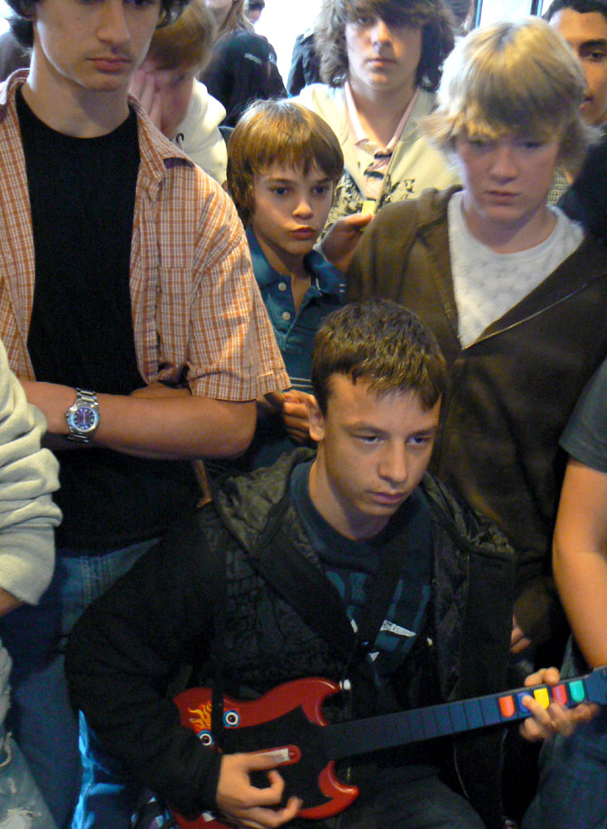

Marking Scheme

Application Criteria: | Level 4  14-15 mrks | Level 3  11-13 mrks | Level 2  10-12 mrks | Level 1  7-9 mrks | Below Level 1
- Used the principles, tips and knowledge about photography to take the photographs | Used all principles, applied all knowledge | Used most principles, applied most knowledge | Used some principles, applied some knowledge | Used limited number of principles, applied limited knowledge | Did not complete
Knowledge/Understanding Criteria:
- Correct use of terminology when explaining photos. | Used all terminology correctly | Used most terminology correctly | Used some terminology correctly | Used limited terminology correctly | Did not complete
- 3 photos – at least one candid and one posed, at least one with flash, one without, indoor photos | Followed all criteria | Followed most criteria | Followed some criteria | Followed limited criteria | Did not complete
- Followed instructions of the assignment | Followed all instructions | Followed most instructions | Followed some instructions | Followed few instructions | Did not complete

