Clone images or areas in an image

The Clone Stamp tool paints with an image sample, which you can use to duplicate objects, remove image imperfections, or paint over objects in your photo.
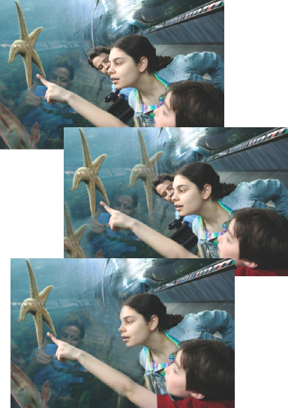
Original photo (top), after adding two starfish with the Clone Stamp tool (center), and after removing a person with the Clone Stamp tool (bottom).
- In the Editor, select the Clone Stamp tool .
- (Optional) Set options in the options bar:
Brushes
Sets the brush tip. Click the arrow next to the brush sample, choose a brush category from the Brushes pop-up menu, and then select a brush thumbnail.
Size
Sets the size of the brush in pixels. Drag the Size pop-up slider or enter a size in the text box.
Mode
Determines how the source or pattern blends with existing pixels. Normal mode lays new pixels over the original pixels.
Opacity
Sets the opacity of the paint you apply. A low opacity setting allows pixels under a paint stroke to show through. Drag the pop-up slider or enter an opacity value.
Aligned
Moves the sampled area with the cursor as you begin to paint, regardless of how many times you stop and resume painting. Selecting this option is useful when you want to eliminate unwanted areas, such as a telephone line across the skyline or a rip in a scanned photo. If Aligned is deselected, the Clone Stamp tool applies the sampled area from the initial sampling point each time you stop and resume painting. Deselecting this option is useful for applying multiple copies of the same part of an image to different areas within the same image or to another image.
Sample All Layers
To sample (copy) data from all visible layers, select Sample All Layers. To sample data from only the active layer, deselect this option.
- Position the pointer on the part of any open image you want to sample, and Alt-click. The tool duplicates the pixels at this sample point in your image as you paint.
- Drag or click to paint with the tool.

