Use the Cookie Cutter tool

The Cookie Cutter tool crops a photo into a shape that you choose. After you drag the shape in your photo, you can move and resize the bounding box until you have just the area you want.
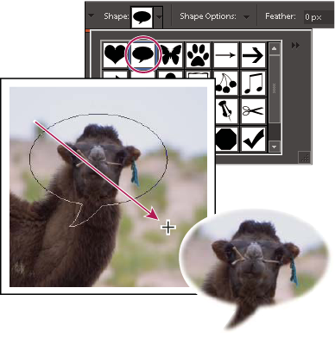
Use the Cookie Cutter tool to clip a photo into a fun shape.
- In the Editor, select the Cookie Cutter tool .
- Click the Shapes menu in the options bar to view a library of shapes from which to choose. To view other libraries, click the triangle on the right side of the currently open library and choose a new library from the list that appears.
- Double-click a shape to select it.
- Set Shape Options:
Unconstrained
Draws the shape to any size or dimension.
Defined Proportions
Keeps the height and width of the cropped shape in proportion.
Defined Size
Crops the photo to the exact size of the shape you chose.
Fixed Size
Specifies the exact measurements of the finished shape.
From Center
Draws the shape from the center.
- Enter a value for Feather to soften the edges of the finished shape.
Note: Feathering softens the edges of the cropped image so that the edges fade out and blend into the background.
- Drag within the image to create the shape boundary and move it to the desired location in the image.
- Click the Commit button , or press Enter to finish the cropping. If you want to cancel the cropping operation, click the Cancel button or press Esc.

