PhotoShop

Activity #3 - Recomposing

For a video about this process, see www.adobe.com/go/lrvid2341_pse8_en.
The Recompose tool facilitates intelligent resizing of photos without changing important visual content such as people, building, animals, and so on. Normal scaling affects all pixels uniformly when resizing an image. Recompose affects pixels in areas that don’t have important visual content. Recompose enables you to upscale or downscale images to improve a composition, fit a layout, or change the orientation.
Note: Recompose can also be performed without using the protect areas option. For example, to recompose a photo without marking any areas for protection or removal, drag the image handles .
View full size graphic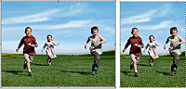
Before Recompose (left) and after Recompose
If you want to preserve or remove specific areas when scaling an image, Recompose enables you to protect content intelligently during resizing.
View full size graphic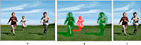
A.
Photo selected for Recompose
B.
Areas marked for protection (green) and for removal (red)
C.
Photo after Recompose
- Recompose a photo in Guided Edit
- Recompose a photo in Full Edit
- Recompose a photo in a photo project
- Recompose options

