The follow The following are the Chart of Accounts and Trial Balance for Fitzgerald, Tattoo Artist. Charlie Fitzgerald is a tattoo artist who works out of a small store front. Below are the Chart of Accounts and Trial Balance for Fitzgerald, Tattoo Artist. Charlie Fitzgerald is a tattoo artist who works out of a small store front. | 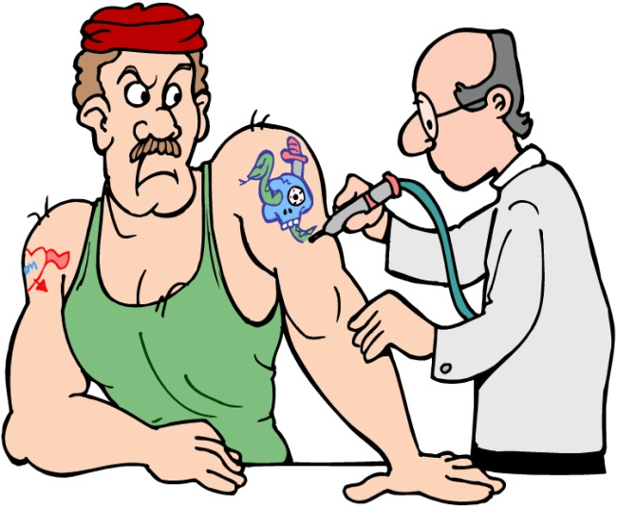
Instructions
You are Charlie Fitzgerald’s bookkeeper. Use the template provided and do the following:
- Record the journal entries. Use explanations for each entry.
- Set up the ledger using the Chart of Accounts. The accounts in the ledger will be in the same order as the Chart of Accounts.
- Record the opening balances from the Trial Balance in the ledger.
- Post the journal entries in the ledger.
- Do an equality check to ensure that the debits equal credits in the ledger. This is a check to ensure the ledger is in balance. Add all the debits in one column. Add all of the credits in another column. The totals of both columns should be equal. If not, there is an error.
Chart of Accounts
No. | Account
101 | Bank
110 | AR – P. Brown
115 | Supplies
120 | Equipment
205 | A/P – Gravel Co.
250 | HST Payable
255 | HST Recoverable
305 | C. Fitzgerald, Capital
310 | C. Fitzgerald, Drawings
405 | Tattoo Revenue
505 | Auto Expense
510 | Wages
Fitzgerald, Tattoo Artist
Trial Balance
As at September 30, 2013
No. | Account | Debit | Credit
101 | Bank | 2900.00
110 | AR – P. Brown | 370.00
115 | Supplies | 1420.00
120 | Equipment | 9075.00
205 | A/P – Gravel Co. |  | 2030.00
250 | HST Payable |  | 245.00
255 | HST Recoverable | 43.00
305 | C. Fitzgerald, Capital |  | 11533.00
310 | C. Fitzgerald, Drawings
 | Totals | 13808.00 | 13808.00

 | Here are the transactions for October, 2013
Oct 4 | Completed a tattoo of an eagle on the forearm of Tyler Gill for cash. Sold tattoo/tattoo service for $120.00 plus HST.
Oct 7 | Paid wages for previous week, $475.00
Oct 7 | Paid Gravel Co. $1500.00 on account.
Oct 10 | Received payment in full from Paul Brown on account.
Oct 15 | Purchased Supplies for $500.00 plus HST. Purchased from Gravel Co. on account.
Oct 21 | Completed a tattoo of a dragon on the forearm of Paul Brown. Sold tattoo/tattoo service for $125.00 plus HST on account.
Oct 25 | Charlie withdrew $350.00 cash for personal use.
Oct 30 | Paid the HST owing from September by cheque. (Use the September HST balances.
Oct 30 | Purchased gas for the company vehicle - $48.00 plus HST. Paid by cheque.

