Unit 4: The Accounting Cycle

Activity 3: The Balance Sheet
- What is an account form balance sheet?

- What type of balance sheet are we going to study in this Unit?

- Fill in the blank: The accounting equation Assets = Liabilities + Owner’s Equity is ___________ no matter how the balance sheet is ______________.

- Fill in the following features of a report form balance sheet:
- Total Assets = Total __________________ and Owner’s Equity (i.e. both are $5,035).
- Both final totals are ________________ underlined.
- Both final totals are in the _______________ column.
- Final totals are formatted with a __________________ ___________ ($).
- A classified balance sheet groups various balance sheet accounts into these categories.
- Current Assets –

- Fixed Assets –

- Current Liabilities –

- Long-Term Liabilities –

- Owner’s Equity –

- Net income ___________________ owner’s equity.
- Drawings ____________________ owner’s equity.

- Here is a close up look at the Owner’s Equity section on the balance sheet. Please memorize this format.
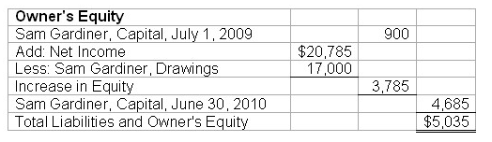

Check Your Understanding
- A 20 year mortgage is a________________ .
  - current asset
  - fixed asset
  - current liability
  - long-term liability

- Drawings _________ owner’s equity.
  - increase
  - decrease
  - do not affect

- Cash is a _____________ .
  - current asset
  - fixed asset
  - current liability
  - long-term liability

*Please go back to my website and complete the Classified Balance Sheet Assignment. There are three (3) tabs along the bottom of the spreadsheet. #1 Worksheet, #2 Income Statement, #3 Balance Sheet. Please use the worksheet and the income statement to complete the Classified Balance Sheet.

