Unit 2 COMIC STRIP Bonus Mark ASSIGNMENT
Using the terminology from Unit 2 (Chapters 5 & 8) please create an “informational” cartoon. You may use the software program of your choice (Comic Life is a good one!) Be creative and have fun!!
Educational Comic Strip
This assignment requires the student to create an educational comic strip using the chosen sub-topic and supporting details from Chapters 5 & 8. This assignment is designed to both enhance students learning on Factors of Production and Marketing concepts, as well as help foster and develop reading and writing skills necessary for success.
STEPS TO SUCCESS
- Review the main topic, your chosen sub-topic and supporting details from Chapters 5 & 8
- Create a story line with 3 or more characters
- Create a “catchy” title
- Include an “educational message statement”
- Include at least four words/terminology from each chapter
- Creatively lay-out all required components in a comic strip (8.5X11 paper- at least six frames)
- Re-read your comic strip and check for spelling, grammar, and punctuation

How to Create a Comic in Comic Life
Creating a comic with Comic Life is a simple 5-step process.
- Select a template for your new page. There are over 200 templates in categories such as comics from the 40’s, 60’s and 80’s, manga, graphic novels, and euro comics. Or, you can create your own layout by dragging panels anywhere you want them.
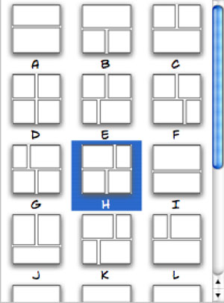
- Add digital images from iPhoto, other disks or a connected digital camera. You can drag and drop images from the interface of Comic Life (from your iPhoto library or any connected disk), or you can drag items directly from the Finder into Comic Life. If you’d like to capture images directly from a camcorder or camera, such as an iSight, you can use the capture feature of Comic Life and create your comic with images you grab on the fly.
Dragging an image onto a panel will put the image into the panel and crop it so the shortest dimension of the image matches the shortest dimension of the panel. You can adjust the panel size/shape separately from the image’s size.
- Select a style/filter for digital images. You can leave your images in their unfiltered state, but Comic Life's built-in filters and styles give you some very cool control over how 'comicy' your comic looks. If you don’t like the pre-defined styles, you can enter your own filter settings to get that perfect look.
Don’t overlook the fact that you can draw your own images (on the computer, or on paper and scan them in) and then include them in your comic once they are in a digital format.
- Add text containers and text. Just like almost everything else in Comic Life, adding text is a simple drag and drop process. The text containers at the bottom of the window provide you with different text presentations.
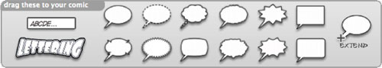
Drag a container into your page and enter your text. If you have a balloon selected, you can drag the tail to associate the speech or thought with a particular character in an image. Additional tails can be added for more than one speaker at a time. Other text containers have options for styles and effects to enhance the text. The controls allow you to stretch, scale, skew, colorize, outline, shade and too many other options to list. The pre-defined options are numerous and individual controls let you take them further.
Nothing says WOW like...
- Save (frequently) and export to your format of choice. Your export decisions will be based on what you intend to do with the comic when you’re done. Comic Life has several export options that allow you to share your work in digital or paper/printed form. The HTML export creates an interface that allows users to ‘flip’ through your comic page-by-page. Exporting to an album in iPhoto lets you build a quality book and then have it printed by Kodak. (If you’re not using iPhoto for that by now, you better look into it!)

Other Uses for Comic Life
Your imagination is the only thing that limits what you can do with Comic Life. As some of you may have discovered by reading this article, you can create graphics for use on web pages (or other publications) that would be time consuming to create with other tools. Want to show off something that is new or improved? No problem!
Spice up your images, documents, brochures and web pages. Just try not to use New and Improved together. If it’s new, there was nothing to improve upon and if it’s improved then it’s not new; it’s something old that was improved!

Tell Your Story with a Comic
When my family was in China to adopt our youngest daughter, we had some problems with the Citizenship and Immigration Services department (which was no surprise to us). To express our frustration and enduring sense of humor, I created a comic to share with family and friends regarding our most recent difficulty. I’ve included it here as an example of a quick and simple comic used to tell a short story.
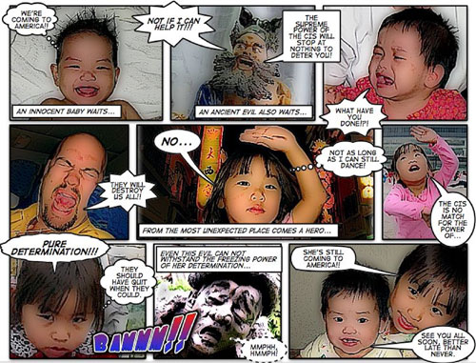
Click here for a larger version of this strip.

