Unit 3: Income Statement Transactions (T – Account, Trial Balance, Formal Journal and Ledger)

Activity 4: The Capital section of the Classified Balance sheet
- The revenues, expenses and drawings over incurred over a fiscal period can also help _______________________________________________________________________.
- In this activity we will concentrate on the ________________________________________________.
- Here is a close up look at the Owner’s Equity section on the balance sheet.

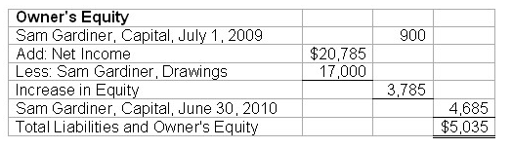

List the six steps in completing the equity/capital section of the balance sheet.
Step 1:

Step 2:

Step 3:

Step 4:

Step 5:

Step 6:

On the next page are assignment instructions. Go back to my website and access the Unit 3 Activity 4 Assignment Template to complete the assignment for today.

